Table S1. Characterization of selected Peptides based on number of amino acids produced by Gram-positive and Gram-negative organisms in the UniProt Database.
No. | ID | Sequence Length | Mass (Da) | Organism
1 | A0A0B7MF59 | 50 | 5,557 | Streptococcus pneumoniae
2 | A0A0E2P8G1 | 50 | 5,550 | Streptococcus pseudopneumoniae 22725
3 | A0A0P0C3P7 | 50 | 5,893 | Staphylococcus pseudintermedius
4 | A0A0U0CP47 | 50 | 5,492 | Streptococcus pseudopneumoniae
5 | A0A1E9GG72 | 50 | 5,544 | Streptococcus sp. HMSC073F11
6 | A0A1S9ZCG0 | 50 | 5,529 | Streptococcus mitis
7 | A0A4U1LBM3 | 50 | 5,544 | Streptococcus mitis
8 | A0A6G2DJX7 | 50 | 5,588 | Streptococcus pneumoniae
9 | A0A6I1TUZ4 | 50 | 5,528 | Streptococcus mitis
10 | A0A150NII9 | 50 | 5,192 | Streptococcus mitis
11 | B1I839 | 50 | 5,558 | Streptococcus pneumoniae (strain Hungary19A-6)
12 | B3A0N4 | 43 | 4,449 | Weissella paramesenteroides (Leuconostoc paramesenteroides)
13 | B3EWP5 | 10 | 1,087 | Lacticaseibacillus paracasei (Lactobacillus paracasei)
14 | B3EWP7 | 15 | 1,803 | Bacillus licheniformis
15 | C0HJC0 | 30 | 3,498 | Lactiplantibacillus plantarum
16 | C0HJE5 | 15 | 1,618 | Bacillus subtilis
17 | C0HK82 | 47 | 4,448 | Latilactobacillus curvatus
18 | C0HL39 | 30 | 2,884 | Bacillus subtilis
19 | C0HLT6 | 10 | 1,067 | Lactiplantibacillus plantarum
20 | C0HLU4 | 38 | 4,264 | Weissella confusa (Lactobacillus confusus)
21 | C1CAF2 | 50 | 5,558 | Streptococcus pneumoniae (strain 70585)
22 | C1CBU6 | 50 | 5,557 | Streptococcus pneumoniae
23 | C6FX52 | 50 | 5,364 | Streptomyces actuosus
24 | D3VML5 | 41 | 4,366 | Bacillus velezensis
25 | E0Q3I4 | 47 | 5,235 | Streptococcus sp. oral taxon 071 str. 73H25AP
26 | E8K1W4 | 41 | 4,986 | Streptococcus infantis ATCC 700779
27 | E9FQC5 | 50 | 5,205 | Streptococcus sp. M334
28 | J1P1V9 | 50 | 5,558 | Streptococcus pneumoniae 2070335
29 | O07623 | 43 | 4,325 | Bacillus subtilis (strain 168)
30 | P0C8P6 | 14 | 1,416 | Bacillus cereus
31 | P0C8P7 | 14 | 1,416 | Bacillus badius
32 | P0C912 | 14 | 1,365 | Amycolatopsis sp. (strain MI481-42F4 / FERM P-12739)
33 | P0DQM5 | 47 | 5,013 | Burkholderia thailandensis
34 | P01547 | 45 | 4,680 | Myxococcus fulvus
35 | P02987 | 49 | 5,157 | Escherichia coli
36 | P36499 | 50 | 5,677 | Lactococcus lactis subsp. lactis (Streptococcus lactis)
37 | P36502 | 19 | 2,063 | Streptomyces sp. (strain R2075) (Streptoverticillium sp. (strain R2075))
38 | P36503 | 19 | 2,007 | Streptomyces griseoluteus
39 | P36504 | 19 | 2,069 | Streptomyces griseoverticillatus
40 | P36961 | 39 | 4,346 | Lactococcus lactis subsp. lactis (Streptococcus lactis)
41 | P36962 | 35 | 4,110 | Lactococcus lactis subsp. lactis (Streptococcus lactis)
42 | P42723 | 42 | 4,406 | Rhizobium leguminosarum bv. trifolii
43 | P80214 | 48 | 5,458 | Lactiplantibacillus plantarum
44 | P80323 | 38 | 3,431 | Latilactobacillus curvatus
45 | P80493 | 42 | 4,402 | Latilactobacillus sakei
46 | P80666 | 22 | 2,425 | Streptococcus mutans
47 | P80925 | 43 | 4,290 | Enterococcus mundtii
48 | P80953 | 41 | 4,061 | Latilactobacillus sakei
49 | P80959 | 31 | 3,358 | Lacticaseibacillus paracasei
50 | P81052 | 31 | 3,466 | Leuconostoc mesenteroides
51 | P81053 | 43 | 4,598 | Leuconostoc mesenteroides
52 | P83002 | 37 | 4,145 | Lactococcus lactis subsp. lactis (Streptococcus lactis)
53 | P83375 | 9 | 1,095 | Serratia plymuthica
54 | P83378 | 22 | 2,545 | Serratia plymuthica
55 | P83674 | 47 | 5,360 | Ruminococcus gnavus
56 | P84763 | 18 | 2,027 | Bacillus thuringiensis subsp. entomocidus
57 | P84886 | 30 | 3,024 | Latilactobacillus curvatus
58 | P84962 | 43 | 4,525 | Carnobacterium divergens
59 | P85065 | 24 | 2,355 | Microbispora sp. (strain 107891)
60 | P85148 | 39 | 4,126 | Enterococcus faecium
61 | P85833 | 29 | 3,353 | Lactococcus lactis subsp. lactis (Streptococcus lactis)
62 | P85876 | 38 | 3,932 | Enterococcus faecium
63 | P86291 | 41 | 4,602 | Lactococcus sp.
64 | P86386 | 25 | 2,728 | Streptococcus mutans
65 | P86393 | 39 | 4,630 | Paenibacillus polymyxa
66 | P86394 | 35 | 3,629 | Niallia circulans (Bacillus circulans)
67 | P86395 | 30 | 3,466 | Paenibacillus polymyxa
68 | P86526 | 13 | 1,414 | Lacticaseibacillus rhamnosus
69 | Q7M0J8 | 14 | 1,413 | Planobispora rosea
70 | Q48501 | 46 | 5,331 | Lactobacillus acidophilus
71 | S7Z987 | 50 | 5,511 | Streptococcus mitis 29/42
72 | V8IIJ8 | 50 | 5,492 | Streptococcus pseudopneumoniae 5247

Table 3: Antimicrobial bacteriocins with their sequence and 3D structures
No. | UniProt ID | AMP Score | Sequence length | Sequence | 3D Structure
1 | A0A0B7MF59 | 0.556 | 50 | MMKNLNNYREISNKELQEIKGGFGVGVGIALFMAGYTIGKDLRKKFGKSC | 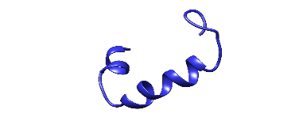
2 | A0A0B7MF59m | 0.507 | 50 | MMKNLNNYHEISNKELQEIKGGFGVGVGIALFMAGYTIGKDLRKKFGKSC
3 | A0A1S9ZCG0 | 0.509 | 50 | MMKDLNNYREISNKELQEIKGGFGAGVGIALFMAGYTIGKDLRKKFGKSC | 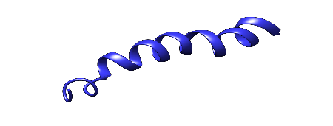
4 | A0A1S9ZCG0m | 0.579 | 50 | MVKDLNNYREISNKELQEIKGGFGAGVGIALFMAGYTIGKDLRKKFGKSC | 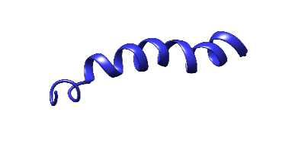
5 | A0A6I1TUZ4m | 0.581 | 50 | MMKGLNNYREITNKELQEIKGGFGVGVGIALFMIAYTIGKDLRKKFGKSC | 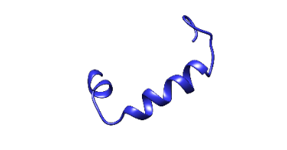
6 | B3A0N4 | 1.084 | 43 | KNYGNGVYCNKHKCSVDWATFSANIANNSVAMAGLTGGNAGNK | 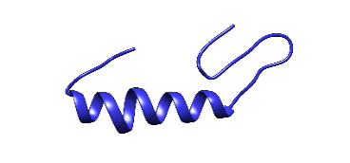
7 | B3A0N4m | 1.409 | 43 | KNYGNGVYCNKHKCSVDWATFSANIANFSVAMAGLTGGNAGNK | 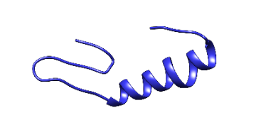
8 | C0HJC0 | 0.506 | 30 | GRADYNFGYGLGRGTRKFFNGHGRWVRKTF | 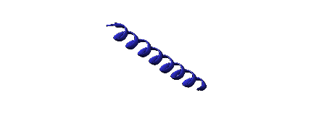
9 | C0HL39m | 0.597 | 30 | LGFQLNKGCATCSIGAACLVDGPIPDEIAG | 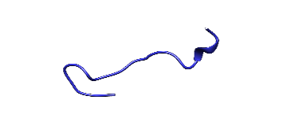
10 | C1CBU6 | 0.556 | 50 | MMKNLNNYREISNKELQEIKGGFGVGVGIALFMAGYTIGKDLRKKFGKSC | 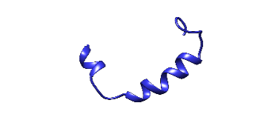
11 | J1P1V9m | 0.542 | 50 | MMKHLNNYREISNKELQEIKGGFGVGVGIALFMAGYTIGKDLRKKFGKSC | 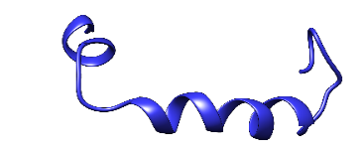
12 | O07623m | 0.832 | 43 | MKKAVIVENKGCATCSIGAACLVDGPIKDFEIAGATGLFGLWG | 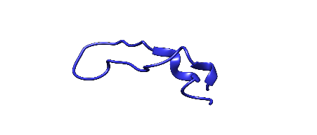
13 | P01547 | 0.961 | 45 | ANCSCSTASDYCPILTFCTTGTACSYTPTGCGTGWVYCACNGNFY | 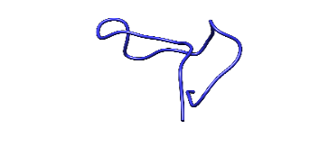
14 | P01547m | 1.048 | 45 | ANCSRSTASDYCPILTFCTTGTACSYTPTGCGTGWVYCACNGNFY | 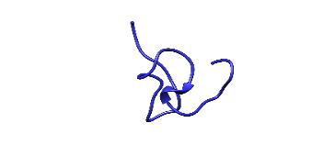
15 | P36502 | 1.648 | 19 | CRQSCSFGPLTFVCDGNTK | 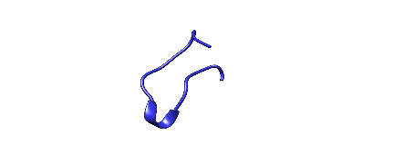
16 | P36502m | 1.560 | 19 | CRQSCSFGYLTFVCDGNTK | 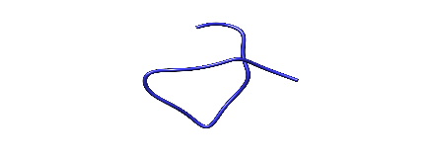
17 | P36503 | 1.298 | 19 | CANSCSYGPLTWSCDGNTK | 
18 | P36503m | 0.837 | 19 | CALSCSYGPLTWSCDGNTK | 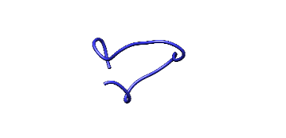
19 | P36504 | 1.002 | 19 | CKQSCSFGPFTFVCDGNTK | 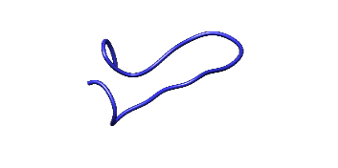
20 | P36504m | 0.743 | 19 | CKQSCSFGPFLFVCDGNTK | 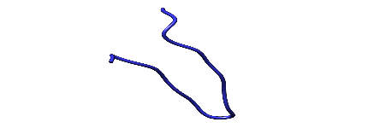
21 | P36961 | 0.923 | 39 | GTWDDIGQGIGRVAYWVGKAMGNMSDVNQASRINRKKKH | 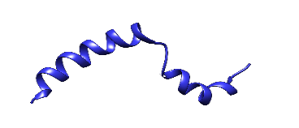
22 | P36961m | 0.733 | 39 | GTWDDIGQGILRVAYWVGKAMGNMSDVNQASRINRKKKH | 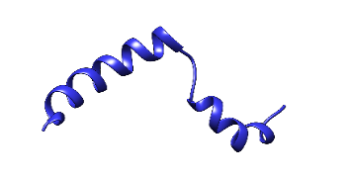
23 | P42723 | 0.661 | 42 | MDNKVAKNVEVKKGSIKATFKAAVLKSKTKVDIGGSRQGCVA | 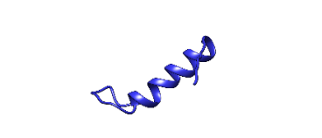
24 | P80214 | 1.190 | 48 | MKIQIKGMKQLSNKEMQKIVGGKSSAYSLQMGATAIKQVKKLFKKWGW | 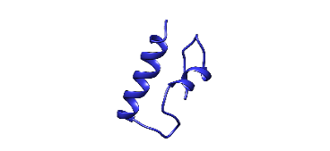
25 | P80214m | 1.312 | 48 | MKIQIKGMKQLSNKEMQKIVGGKSSAYSLQMGATAIFQVKKLFKKWGW | 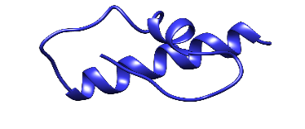
26 | P80666 | 1.000 | 22 | FKSWSFCTPGCAKTGSFNSYCC | 
27 | P80666m | 0.833 | 22 | FKSWSFCTPICAKTGSFNSYCC | 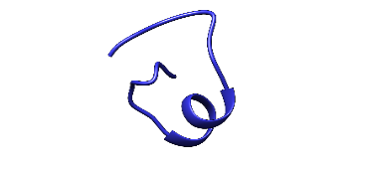
28 | P80925 | 1.576 | 43 | KYYGNGVSCNKKGCSVDWGKAIGIIGNNSAANLATGGAAGWSK | 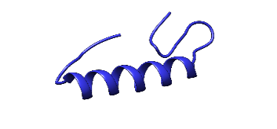
29 | P80925m | 1.697 | 43 | KLYGNGVSCNKKGCSVDWGKAIGIIGNNSAANLATGGAAGWSK | 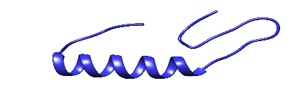
30 | P80959 | 1.193 | 31 | GMSGYIQGIPDFLKGYLHGISAANKHKKGRL | 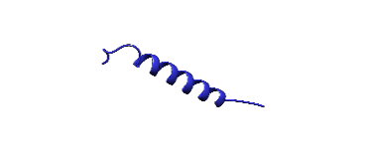
31 | P80959m | 0.949 | 31 | GMSGYIQGIPDFLKGYLHGISAANKHKQGRL | 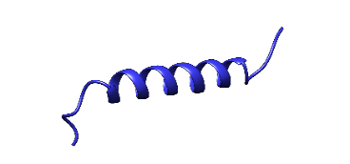
32 | P81053 | 0.986 | 43 | KNYGNGVHCTKKGCSVDWGYAWTNIANNSVMNGLTGGNAGWHN | 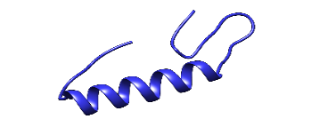
33 | P81053m | 0.925 | 43 | KNLGNGVHCTKKGCSVDWGYAWTNIANNSVMNGLTGGNAGWHN | 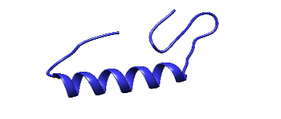
34 | P83002 | 0.959 | 37 | TSYGNGVHCNKSKCWIDVSELETYKAGTVSNPKDILW | 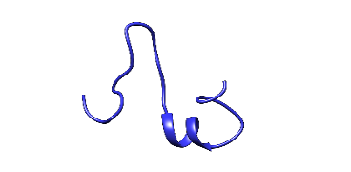
35 | P83002m | 0.546 | 37 | TSYGNGVHCNKSKCWIDVSELETYKAGTVSFPKDILW | 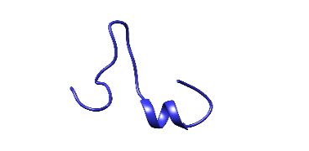
36 | P83378 | 1.001 | 22 | ALPKKLKYLNLFNDGFNYMGVV | 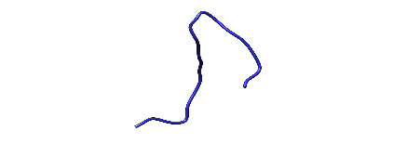
37 | P83378m | 0.522 | 22 | ALPKSLKYLNLFNDGFNYMGVV | 
38 | P84886 | 1.164 | 30 | AYPGNGVHCGKYSCTVDKQTAIGNIGNNAA | 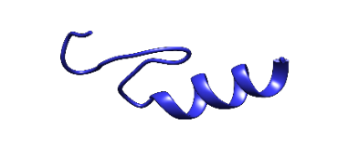
39 | P84886m | 1.340 | 30 | ALPGNGVHCGKYSCTVDKQTAIGNIGNNAA | 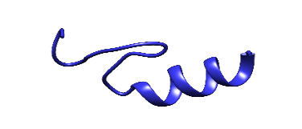
40 | P84962 | 1.000 | 43 | TKYYGNGVYCNSKKCWVDWGTAQGCIDVVIGQLGGGIPGKGKC | 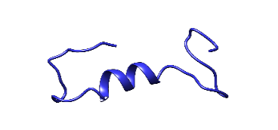
41 | P84962m | 1.061 | 43 | TKYAGNGVYCNSKKCWVDWGTAQGCIDVVIGQLGGGIPGKGKC | 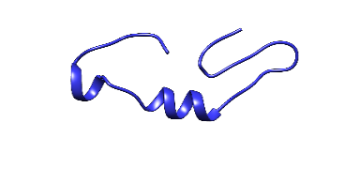
42 | P85065m | 0.515 | 24 | VTSWSLCTPGCTSFGGGSNCSFCC | 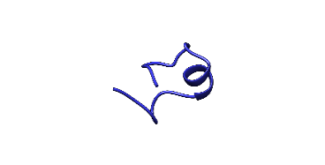
43 | P85148 | 1.039) | 39 | TTKNYGNGVCNSVNWCQCGNVWASCNLATGCAAWLCKLA | 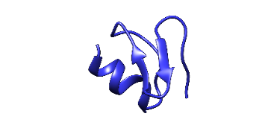
44 | P85148m | 0.920 | 39 | TTKNYGNGVCNSVNWCQCGNCWASCNLATGCAAWLCKLA | 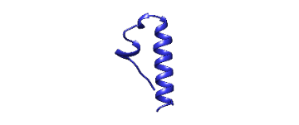
45 | P85876 | 1.270 | 38 | ATRSYGNGVYCNNSKCWNVGEAKENIAGIVISGKASGL | 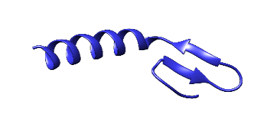
46 | P85876m | 1.315 | 38 | ATRSYGNGVYCNNSKCWNVGEAKENIAGFVFSGKASGL | 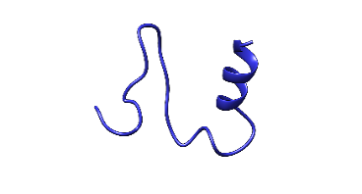
47 | P86291 | 0.551 | 41 | TSYGNGVHCNKSKCWIDVSELETYKAGTVSNPKDILWSLKE | 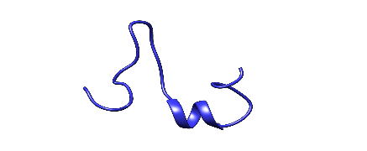
48 | P86291m | 0.587 | 41 | TSYGNGVHCNKSKCWIDVSELETYKAGTVSNPKFILWSLKE | 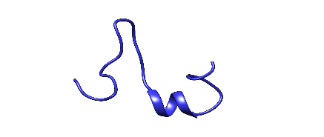
49 | P86393 | 1.005 | 39 | ATYYGNGLYCNKQKHYTWVDWNKASREIGKITVNGWVQH | 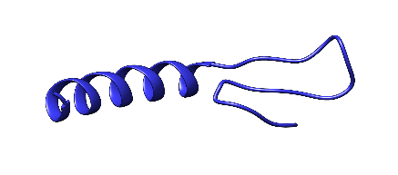
50 | P86393m | 0.927 | 39 | ATYLGNGLYCNKQKHYTWVDWNKASREIGKITVNGWVQH | 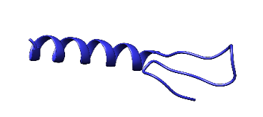
51 | P86394 | 1.057 | 35 | VNYGNGVSCSKTKCSVNWGIITHQAFRVTSGVASG | 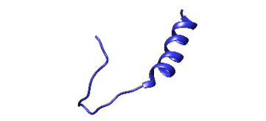
52 | P86394m | 1.010 | 35 | VNYGNGVSCSKTKCSVNWGISTHQAFRVTSGVASG | 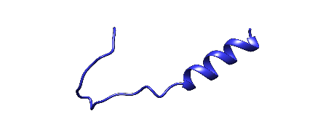
53 | S7Z987 | 0.781 | 50 | MIKDLNNYREISNKELQEIKGGFGAGVGIALFMAGYTIGKDLRKKFGKSC | 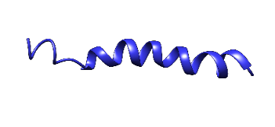
54 | S7Z987m | 0.521 | 50 | MIKDLNNYREISNKELQEIKGGFGAGVGIALFMAGYTIGKDLRYKFGKSC | 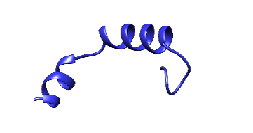
55 | V8IIJ8m | 0.519 | 50 | MLKDLNNYCEISTKELQEIKGGFGVGVGIALFMAGYTIGKDLRKKFGKSC | 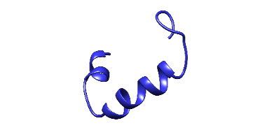

Table S3: Virulent proteins present in Serratia marcescens and their physiochemical properties
No. | ID | Molecular Weight (Da) | Theoretical PI | Instability index | Extinction coefficients | GRAVY
1 | UPI0002AF2D88 | 32230.53 | 4.99 | 46.73 | 0.509 | 0.303
2 | UPI0002AF3E70 | 43195.42 | 5.13 | 28.76 | 0.441 | -0.153
3 | UPI0002AF25B6 | 36786.57 | 5.36 | 23.48 | 1.165 | -0.174
4 | UPI0002AF42AC | 27628.2 | 5.27 | 51.19 | 1.083 | -0.497
5 | UPI0002AF278A | 27862.93 | 4.62 | 27.77 | 0.518 | -0.34
6 | UPI0002AF352E | 38210.07 | 4.81 | 53.78 | 0.705 | -0.539
7 | UPI0002AF3971 | 37957.56 | 9 | 31.11 | 0.23 | 0.174
8 | UPI0002AF4256 | 59164.94 | 5.9 | 37.52 | 1.686 | -0.402
9 | UPI0002AF4326 | 23738.69 | 6.75 | 32.63 | 0.546 | 0.002
10 | UPI0002B86BA6 | 48972.25 | 6.29 | 47.66 | 0.571 | -0.051
11 | UPI0002B88CF4 | 33642.28 | 7.82 | 43.07 | 0.814 | -0.273
12 | UPI0002B87870 | 42206.51 | 8.41 | 36.7 | 0.742 | 0.089
13 | UPI0002C18763 | 47271.17 | 5.27 | 30.16 | 1.506 | -0.196
14 | UPI0002DC8D87 | 25635.4 | 5.95 | 20.21 | 0.447 | 0.2
15 | UPI0002E08E29 | 54743.61 | 5.38 | 40.39 | 1.114 | -0.154
16 | UPI0002E65B3D | 50931.39 | 5.25 | 25.39 | 0.502 | 0.032
17 | UPI0002F3BD56 | 42785.47 | 9.66 | 45.41 | 1.015 | 0.011
18 | UPI0002F98715 | 56658.38 | 5.05 | 47.43 | 1.311 | -0.532
19 | UPI0003C9AF1D | 52615.25 | 6.41 | 53.93 | 3.039 | -0.445
20 | UPI0003C9BA85 | 73818.73 | 5.68 | 23.04 | 1.534 | -0.512
21 | UPI0003C9C1DC | 92534.12 | 5.55 | 32.34 | 1.608 | -0.405
22 | UPI0003C9C802 | 32747.57 | 5.6 | 37.95 | 1.176 | -0.169
23 | UPI0003C9C858 | 99789.17 | 6.11 | 36.97 | 1.058 | 0.172
24 | UPI0003C9CE2E | 48794.87 | 5.97 | 27.16 | 0.588 | -0.048
25 | UPI0003C9D4FC | 92283.32 | 6.59 | 26.12 | 1.363 | -0.388
26 | UPI0003C9D160 | 25445.28 | 6.08 | 35.19 | 0.784 | -0.252
27 | UPI0003C9E72D | 165116.71 | 8.82 | 24.08 | 0.444 | -0.554
28 | UPI0003C9E649 | 54852.47 | 6.15 | 33.88 | 1.166 | -0.629
29 | UPI0003C9EDE5 | 49575.12 | 6.4 | 25.4 | 0.842 | -0.045
30 | UPI0003C95C92 | 33949.88 | 5.53 | 39.43 | 0.551 | -0.052
31 | UPI0003C95D10 | 52721.57 | 6.13 | 44.49 | 0.633 | -0.065
32 | UPI0003C95E0A | 39726.64 | 5.45 | 42.78 | 1.722 | -0.285
33 | UPI0003C97B07 | 47688.62 | 9.58 | 39.06 | 1.017 | -0.044
34 | UPI0003C97E1F | 111609.1 | 5.65 | 34.99 | 0.773 | 0.251
35 | UPI0003C99A74 | 30686.31 | 5.41 | 29.6 | 0.198 | -0.011
36 | UPI0003C953F8 | 313314.86 | 5.41 | 46.08 | 1.031 | -0.16
37 | UPI0003C967AA | 49222.6 | 9.11 | 35.81 | 1.308 | 0.263
38 | UPI0003C982D4 | 71335.45 | 5.4 | 31.67 | 1.582 | -0.509
39 | UPI0003C992A0 | 84289.03 | 5.87 | 35.21 | 0.409 | -0.303
40 | UPI0003C9590B | 33340.73 | 5.85 | 35.18 | 0.695 | -0.102
41 | UPI0003C9723E | 80166.9 | 6.28 | 39.18 | 0.778 | -0.182
42 | UPI0003C9725E | 32808.23 | 6.27 | 29.71 | 0.783 | -0.044
43 | UPI0003C9839B | 52187.73 | 4.64 | 24.32 | 1.386 | -0.392
44 | UPI0003C94769 | 50540.6 | 5.22 | 29.12 | 0.833 | -0.196
45 | UPI0003C95066 | 57890.07 | 6.11 | 44.83 | 1.559 | -0.406
46 | UPI0003C98210 | 87545.47 | 5.67 | 26.49 | 1.437 | -0.55
47 | UPI0003C99600 | 60141.85 | 4.92 | 40.54 | 0.547 | -0.128
48 | UPI000012A963 | 21809.64 | 8.87 | 45.84 | 1.115 | -0.002
49 | UPI000320AA72 | 55709.48 | 6.53 | 35.67 | 1.932 | 0.624
50 | UPI000320ADAB | 93267.75 | 5.69 | 34.75 | 1.571 | -0.431
51 | UPI000320CDF9 | 32400.77 | 4.68 | 52.69 | 1.564 | -0.275
52 | UPI000320FFD4 | 111696.07 | 5.41 | 32.15 | 0.617 | 0.392
53 | UPI000321B1CB | 101694.21 | 5.51 | 43.58 | 0.416 | -0.094
54 | UPI000321CC59 | 143884.12 | 5.34 | 36.37 | 1.09 | -0.05
55 | UPI000322E099 | 95038.34 | 8.23 | 32.8 | 0.96 | -0.092
56 | UPI000322F750 | 58166.99 | 4.77 | 20.81 | 0.479 | -0.376
57 | UPI000323D213 | 53516.47 | 4.66 | 38.49 | 0.72 | -0.364
58 | UPI000323EE92 | 39365.14 | 5.2 | 35.5 | 1.663 | -0.238
59 | UPI000324AAB7 | 110572.43 | 8.98 | 37.35 | 0.596 | 0.296
60 | UPI000324CA26 | 135143.64 | 8.58 | 34.25 | 1.324 | -0.27
61 | UPI000324DAE7 | 41918.13 | 5.76 | 40.56 | 0.659 | -0.103
62 | UPI000325E0FA | 92142.77 | 5.69 | 31.87 | 1.479 | -0.4
63 | UPI000326AD5D | 41726.71 | 6.33 | 34.26 | 1.255 | -0.21
64 | UPI000326D3C8 | 113221.97 | 6.34 | 46.15 | 1.084 | -0.159
65 | UPI0003211BB5 | 45918.15 | 5.61 | 42.88 | 0.672 | -0.258
66 | UPI0003213C38 | 82299.04 | 5.17 | 32 | 1.55 | -0.519
67 | UPI0003224D5E | 53029.24 | 5.52 | 36.96 | 0.984 | -0.184
68 | UPI0003227B2E | 57356.99 | 4.89 | 29.16 | 0.21 | 0.018
69 | UPI0003229BFB | 50493 | 4.55 | 21.85 | 1.264 | -0.371
70 | UPI0003235D33 | 36028.5 | 4.93 | 26 | 1.445 | -0.321
71 | UPI0003236E46 | 37704.23 | 5.23 | 39.56 | 0.568 | -0.19
72 | UPI0003236F10 | 84272.26 | 6.15 | 38.95 | 1.079 | -0.36
73 | UPI0003245BEC | 36613.8 | 4.65 | 46.77 | 0.163 | -0.163
74 | UPI0003246B37 | 49786.64 | 5.92 | 48.59 | 1.619 | -0.261
75 | UPI0003251A93 | 112931.17 | 5.78 | 32.07 | 0.721 | 0.28
76 | UPI0003259EC6 | 32073.91 | 5.81 | 39.95 | 1.076 | -0.053
77 | UPI0003261DB2 | 42571.03 | 6.87 | 40.36 | 1.056 | -0.183
78 | UPI0003262E92 | 91538.01 | 8.33 | 35.48 | 1.256 | -0.356
79 | UPI00032087BB | 72878.04 | 9.4 | 37.26 | 2.301 | 0.539
80 | UPI00032128B6 | 61170.15 | 5.89 | 31.48 | 1.267 | -0.268
81 | UPI00032189DE | 112422.67 | 7.01 | 34.27 | 0.75 | 0.332
82 | UPI00032237FC | 26520.96 | 4.96 | 35.12 | 0.169 | -0.234
83 | UPI00032291F5 | 52656.09 | 5.57 | 41.52 | 1.109 | -0.198
84 | UPI00032325DB | 107539.05 | 4.87 | 41.5 | 0.824 | -0.006
85 | UPI00032386A1 | 83329.46 | 6.86 | 39 | 1.024 | 0.439
86 | UPI00032427A7 | 33087.79 | 9.44 | 30.1 | 1.119 | -0.303
87 | UPI00032500A3 | 82587.34 | 6.5 | 32.25 | 1.378 | -0.574
88 | UPI00032555AB | 110446.43 | 6.04 | 37.2 | 0.678 | 0.36
89 | UPI00032589FC | 42638.09 | 5.02 | 26.76 | 0.677 | -0.336
90 | UPI00032621DF | 48874.27 | 6.15 | 36.04 | 1.302 | -0.331
91 | UPI00032632F6 | 49390.58 | 4.49 | 19.84 | 1.594 | -0.456
92 | UPI00032637BE | 27676.29 | 9.05 | 48.83 | 0.865 | 0.777
93 | UPI00032649DA | 32665 | 5.6 | 34.96 | 0.618 | -0.026
94 | UPI000321385E | 91236.31 | 6.17 | 33.03 | 1.446 | -0.372
95 | UPI000322301E | 42488.15 | 10.02 | 39.91 | 1.5 | 0.749
96 | UPI000322408E | 59726.6 | 5.16 | 43.51 | 1.008 | -0.193
97 | UPI000324881A | 37695.86 | 8.43 | 42.58 | 0.201 | 0.001
98 | UPI000326241C | 49944.92 | 6.87 | 16.12 | 0.408 | -0.512
99 | UPI000326561B | 36506.65 | 5.61 | 56.94 | 1.055 | -0.32
100 | UPI0003211044 | 38959.03 | 5.95 | 55.59 | 0.615 | -0.485
101 | UPI0003218851 | 38576.49 | 8.27 | 51.76 | 1.221 | -0.129
102 | UPI0003222101 | 39711.76 | 8.9 | 22.43 | 1.547 | -0.333
103 | UPI0003226237 | 113297.76 | 6.2 | 32.49 | 0.843 | 0.192
104 | UPI0003227771 | 57867.08 | 4.85 | 39.42 | 0.416 | -0.077
105 | UPI0003235528 | 91673.41 | 6.08 | 29.33 | 1.547 | -0.402
106 | UPI0003235719 | 79438.9 | 6.37 | 46.1 | 1.713 | -0.513
107 | UPI0003257892 | 41176.94 | 5.99 | 40.25 | 1.102 | -0.067
108 | UPI0003265092 | 80149.13 | 6.19 | 29.28 | 0.678 | -0.133
109 | UPI0003265136 | 28203.26 | 6.89 | 34.79 | 0.837 | 1.06
110 | UPI0003267316 | 64767.18 | 7.08 | 37.82 | 0.703 | 0.103
111 | UPI000313986E | 34472.34 | 4.73 | 34.19 | 0.346 | -0.492

Table S4: Likelihood of Subcellular localization for virulent proteins in Serratia marscens
 | UniProt ID | Extracellular | Periplasmic | Outer Membrane | Cytoplasmic Membrane | Cytoplasmic | Final prediction
1 | UPI0002AF3E70 | 0.00 | 0.01 | 0.00 | 0.01 | 9.97 | Periplasmic
2 | UPI0002AF25B6 | 0.01 | 0.48 | 0.01 | 0.24 | 9.26 | Periplasmic
3 | UPI0002AF278A | 10.00 | 0.00 | 0.00 | 0.00 | 0.00 | Extracellular
4 | UPI0002AF3971 | 0.11 | 9.76 | 0.06 | 0.00 | 0.00 | Periplasmic
5 | UPI0002AF4256 | 0.00 | 0.01 | 0.00 | 0.01 | 9.97 | Periplasmic
6 | UPI0002AF4326 | 0.00 | 0.01 | 0.00 | 0.01 | 9.97 | Periplasmic
7 | UPI0002B87870 | 0.00 | 0.01 | 0.00 | 0.01 | 9.97 | Periplasmic
8 | UPI0002C18763 | 0.00 | 0.01 | 0.00 | 0.01 | 9.97 | Periplasmic
9 | UPI0002DC8D87 | 0.01 | 0.48 | 0.01 | 0.24 | 9.26 | Periplasmic
10 | UPI0002E65B3D | 0.00 | 0.01 | 0.00 | 0.01 | 9.97 | Periplasmic
11 | UPI0003C9BA85 | 0.00 | 0.00 | 10.00 | 0.00 | 0.00 | OuterMembrane
12 | UPI0003C9C1DC | 0.00 | 0.00 | 10.00 | 0.00 | 0.00 | OuterMembrane
13 | UPI0003C9C802 | 0.00 | 0.01 | 0.00 | 0.01 | 9.97 | Periplasmic
14 | UPI0003C9C858 | 0.00 | 0.00 | 0.00 | 10.00 | 0.00 | CytoplasmicMembrane
15 | UPI0003C9CE2E | 0.00 | 0.01 | 0.00 | 0.01 | 9.97 | Periplasmic
16 | UPI0003C9D4FC | 0.00 | 0.00 | 10.00 | 0.00 | 0.00 | OuterMembrane
17 | UPI0003C9D160 | 0.00 | 0.01 | 0.00 | 0.01 | 9.97 | Periplasmic
18 | UPI0003C9E72D | 0.00 | 0.00 | 10.00 | 0.00 | 0.00 | OuterMembrane
19 | UPI0003C9E649 | 0.05 | 4.48 | 0.00 | 0.06 | 5.41 | Unknown(may have multiple site
20 | UPI0003C9EDE5 | 0.00 | 0.01 | 0.00 | 0.01 | 9.97 | Periplasmic
21 | UPI0003C95C92 | 0.00 | 0.01 | 0.00 | 0.01 | 9.97 | Periplasmic
22 | UPI0003C97B07 | 0.26 | 0.26 | 0.01 | 0.51 | 8.96 | Periplasmic
23 | UPI0003C97E1F | 0.00 | 0.00 | 0.00 | 10.00 | 0.00 | CytoplasmicMembrane
24 | UPI0003C99A74 | 0.00 | 0.01 | 0.00 | 0.01 | 9.97 | Periplasmic
25 | UPI0003C967AA | 0.00 | 0.00 | 0.00 | 10.00 | 0.00 | CytoplasmicMembrane
26  27 | UPI0003C982D4 | 0.01 | 0.48 | 0.01 | 0.24 | 9.26 | Periplasmic
 | UPI0003C992A0 | 0.00 | 0.01 | 0.00 | 0.01 | 9.97 | Periplasmic
28 | UPI0003C9590B | 0.00 | 0.01 | 0.00 | 0.01 | 9.97 | Periplasmic
29 | UPI0003C9723E | 0.00 | 0.00 | 0.00 | 10.00 | 0.00 | CytoplasmicMembrane
30 | UPI0003C9725E | 0.00 | 0.01 | 0.00 | 0.01 | 9.97 | Periplasmic
31 | UPI0003C9839B | 10.00 | 0.00 | 0.00 | 0.00 | 0.00 | Extracellular
32 | UPI0003C94769 | 0.00 | 0.01 | 0.00 | 0.01 | 9.97 | Periplasmic
33 | UPI0003C98210 | 0.01 | 0.48 | 0.01 | 0.24 | 9.26 | Periplasmic
34 | UPI000320AA72 | 0.00 | 0.00 | 0.00 | 10.00 | 0.00 | CytoplasmicMembrane
35 | UPI000320ADAB | 0.00 | 0.00 | 10.00 | 0.00 | 0.00 | OuterMembrane
36 | UPI000320FFD4 | 0.00 | 0.00 | 0.00 | 10.00 | 0.00 | CytoplasmicMembrane
37 | UPI000321CC59 | 0.00 | 0.01 | 0.00 | 0.01 | 9.97 | Periplasmic
38 | UPI000322E099 | 0.38 | 0.09 | 9.49 | 0.01 | 0.03 | OuterMembrane
39 | UPI000322F750 | 9.96 | 0.00 | 0.04 | 0.00 | 0.00 | Extracellular
40 | UPI000323D213 | 0.00 | 0.01 | 0.00 | 0.01 | 9.97 | Periplasmic
41 | UPI000323EE92 | 0.00 | 0.01 | 0.00 | 0.01 | 9.97 | Periplasmic
42 | UPI000324AAB7 | 0.00 | 0.00 | 0.00 | 10.00 | 0.00 | CytoplasmicMembrane
43 | UPI000324CA26 | 0.00 | 0.00 | 0.00 | 10.00 | 0.00 | CytoplasmicMembrane
44 | UPI000325E0FA | 0.00 | 0.00 | 10.00 | 0.00 | 0.00 | OuterMembrane
45 | UPI000326AD5D | 0.03 | 0.03 | 9.92 | 0.01 | 0.01 | OuterMembrane
46  47 | UPI0003213C38 | 0.00 | 0.00 | 10.00 | 0.00 | 0.00 | OuterMembrane
 | UPI0003224D5E | 0.26 | 0.26 | 0.01 | 0.51 | 8.96 | Periplasmic
48 | UPI0003227B2E | 0.00 | 0.01 | 0.00 | 0.01 | 9.97 | Periplasmic
49 | UPI0003229BFB | 10.00 | 0.00 | 0.00 | 0.00 | 0.00 | Extracellular
50 | UPI0003235D33 | 0.00 | 0.01 | 0.00 | 0.01 | 9.97 | Periplasmic
51 | UPI0003236E46 | 0.00 | 0.00 | 0.00 | 7.88 | 2.11 | CytoplasmicMembrane
52 | UPI0003236F10 | 0.26 | 0.26 | 0.01 | 0.51 | 8.96 | Extracellular
53 | UPI0003251A93 | 0.00 | 0.00 | 0.00 | 10.00 | 0.00 | CytoplasmicMembrane
54 | UPI0003259EC6 | 0.00 | 0.01 | 0.00 | 0.01 | 9.97 | Periplasmic
55 | UPI0003262E92 | 0.00 | 0.00 | 10.00 | 0.00 | 0.00 | OuterMembrane
56 | UPI00032087BB | 0.00 | 0.00 | 0.00 | 10.00 | 0.00 | CytoplasmicMembrane
57 | UPI00032128B6 | 0.00 | 0.01 | 0.00 | 0.01 | 9.97 | Periplasmic
58 | UPI00032189DE | 0.00 | 0.00 | 0.00 | 10.00 | 0.00 | CytoplasmicMembrane
59 | UPI00032237FC | 0.11 | 9.44 | 0.06 | 0.06 | 0.33 | Periplasmic
60 | UPI00032386A1 | 0.00 | 0.00 | 0.00 | 10.00 | 0.00 | CytoplasmicMembrane
61 | UPI00032427A7 | 0.00 | 0.01 | 0.00 | 0.01 | 9.97 | Periplasmic
62 | UPI00032500A3 | 0.00 | 0.00 | 10.00 | 0.00 | 0.00 | OuterMembrane
63 | UPI00032555AB | 0.00 | 0.00 | 0.00 | 10.00 | 0.00 | CytoplasmicMembrane
64 | UPI00032589FC | 9.84 | 0.16 | 0.00 | 0.00 | 0.00 | Extracellular
65 | UPI00032621DF | 0.01 | 0.48 | 0.01 | 0.24 | 9.26 | Periplasmic
66 | UPI00032632F6 | 10.00 | 0.00 | 0.00 | 0.00 | 0.00 | Extracellular
67 | UPI00032649DA | 0.00 | 0.01 | 0.00 | 0.01 | 9.97 | Periplasmic
68 | UPI000321385E | 0.00 | 0.00 | 10.00 | 0.00 | 0.00 | OuterMembrane
69 | UPI000322301E | 0.00 | 0.00 | 0.00 | 10.00 | 0.00 | CytoplasmicMembrane
70 | UPI000326241C | 9.71 | 0.20 | 0.07 | 0.01 | 0.01 | Extracellular
71 | UPI0003222101 | 0.00 | 0.00 | 10.00 | 0.00 | 0.00 | OuterMembrane
72 | UPI0003226237 | 0.00 | 0.00 | 0.00 | 10.00 | 0.00 | CytoplasmicMembrane
73 | UPI0003227771 | 0.00 | 0.00 | 0.00 | 10.00 | 0.00 | CytoplasmicMembrane
74 | UPI0003235528 | 0.00 | 0.00 | 10.00 | 0.00 | 0.00 | OuterMembrane
75 | UPI0003265092 | 0.00 | 0.00 | 0.00 | 10.00 | 0.00 | CytoplasmicMembrane
76 | UPI0003265136 | 0.00 | 0.00 | 0.00 | 10.00 | 0.00 | CytoplasmicMembrane
77 | UPI0003267316 | 0.00 | 0.00 | 0.00 | 10.00 | 0.00 | CytoplasmicMembrane
78 | UPI000313986E | 10.00 | 0.00 | 0.00 | 0.00 | 0.00 | Extracellular

Table S5: Docking results between protein UPI0002AF278A (Serratia marcescens) and 55 bacteriocins peptides.
Sr # | Peptide ID | Peptide-protein interaction
 |  | Peptide residue | Protein residue | Bond Length(A) | Score
1 | A0A0B7MF59m | No interaction
2 | A0A0B7MF59w | Gly(22) | Phe(41) | 2.21 | -9.47
 |  | Phe(23) | Gln(15) | 3.16
3 | A0A1S9ZCG0 | Leu(16) | Gln(235) | 2.79 | -2.37
4 | A0A1S9ZCG0m | Leu(16) | Gln(235) | 2.79 | -4.64
5 | A0A6I1TUZ4m | Gly(21) | Gln(51) | 2.65 | -6.91
 |  | Leu(31) | Gln(67) | 3.11
 |  | Gly(24) | Gln(67) | 2.54
 |  | Val(27) | Gln(67) | 2.84
6 | B3A0N4 | Trp(18) | Gln(16) | 2.65 | -5.89
 |  | Ser(15) | Asp(20) | 3.23
7 | B3A0N4m | Trp(18) | Gln(16) | 3.20 | -7.93
8 | C0HJC0 | Gly(1) | Asn(232) | 2.93 | -9.92
9 | C0HL39m | Cys(18) | Thr(70) | 2.54 | -2.68
 |  | Thr(11) | Gly(53) | 2.68
10 | C1CBU6 | Gly(22) | Phe(41) | 2.21 | -12.94
 |  | Phe(23) | Gln(15) | 3.16
11 | J1P1V9m | Gly(22) | Phe(41) | 2.21 | -9.34
 |  | Phe(23) | Gln(15) | 3.16
12 | O07623m | Asn(9) | Ser(186) | 2.51 | -1.03
 |  | Leu(38) | Glu(189) | 2.81
13 | P01547 | Cys(18) | Ser(132) | 2.57 | -10.56
 |  | Thr(16) | Ser(131) | 2.58
 |  | Leu(15) | Glu(189) | 2.69
 |  | Tyr(11) | Ser(119) | 2.16
 |  | Val(36) | Ser(30) | 2.45
14 | P01547m | Phe(17) | Ala(39) | 3.22 | -13.40
 |  | Trp(35) | Glu(228) | 3.03
 |  | Thr(16) | Asn(18) | 1.99
15 | P36502 | Cyx(14) | Arg(238) | 3.11 | -15.67
 |  | Ser(6) | Glu(241) | 2.17
 |  | Cyx(5) | Ser(244) | 3.14
 |  | Thr(18) | Glu(241) | 2.57
 |  | Phe(7) | Ser(244 | 2.59
16 | P36502m | No interaction
17 | P36503 | Asn(3) | Gln(15) | 2.60 | -11.84
 |  | Asn(3) | Asn(232) | 3.24
 |  | Cyx(1) | Phe(41) | 2.73
 |  | Tyr(7) | Val(72) | 3.06
 |  | Trp(12) | Gly(69) | 3.09
18 | P36503m | Cys(14) | Leu(45) | 2.65 | -9.92
19 | P36504 | No interaction
20 | P36504m | No interaction
21 | P36961 | Arg(32) | Glu(189) | 2.84 | -4.03
 |  | Asn(34) | Val(187) | 3.11
22 | P36961m | Asn(34) | Asp(101) | 3.03 | -6.87
 |  | Gln(29) | Glu(185) | 2.35
 |  | Ser(25) | Val(187) | 2.56
23 | P42723 | Val(31) | Glu(189) | 2.43 | -15.57
24 | P80214 | Lys(44) | Gln(193) | 2.67 | -4.60
 |  | Lys(40) | Glu(194) | 2.69
25 | P80214m | Trp(46) | Asn(28) | 1.67 | -7.01
 |  | Leu(11) | Glu(189) | 2.16
 |  | Lys(9) | Ser(119) | 3.19
26 | P80666 | Trp(4) | Thr(77) | 2.88 | -10.66
27 | P80666m | Phe(17) | Pro(108) | 2.70 | -10.21
28 | P80925 | Gly(36) | Arg(238) | 3.33 | -4.95
 |  | Asn(32) | Gln(235) | 2.71
 |  | Ser(29) | Val(231) | 2.26
29 | P80925m | Asn(5) | Gln(235) | 2.77 | -5.43
 |  | Asn(5) | Asn(232) | 2.12
 |  | Trp(41) | Phe(41) | 3.15
30 | P80959 | Arg(30) | Ser(186) | 2.77 | -3.70
 |  | His(26) | Ala(76) | 2.85
31 | P80959m | Lys(14) | Gln(237) | 2.67 | -1.87
 |  | Gly(15) | Gln(237) | 1.64
32 | P81053 | Gly(37) | Gln(15) | 2.30 | -14.59
33 | P81053m | Asn(43) | Asp(20) | 3.25 | -7.90
 |  | Asn(32) | Glu(185) | 1.70
34 | P83002 | Asp(17) | Asn(28) | 2.09 | -14.55
 |  | Asp(17) | Asn(24) | 2.77
 |  | Glu(20) | Ser(186) | 2.98
35 | P83002m | Thr(28) | Val(187) | 2.01 | -13.60
 |  | Trp(15) | Glu(189) | 2.83
 |  | Glu(20) | Arg(79) | 2.51
 |  | Asp(17) | Asn(24 | 2.65
36 | P83378 | Asn(13) | Thr(70) | 2.65 | -5.90
37 | P83378m | Gly(15) | Ala(39) | 2.79 | -8.58
 |  | Asn(17) | Ala(39) | 3.10
 |  | Met(19) | Gln(235) | 2.68
38 | P84886 | Tyr(12) | Ser(250) | 2.06 | -4.90
 |  | Tyr(12) | Ala(246) | 2.65
 |  | Asn(5) | Met(49) | 2.74
39 | P84886m | Tyr(12) | Glu(241) | 3.23 | -5.69
40 | P84962 | Gly(24) | Ser(30) | 3.26 | -8.37
 |  | Asp(27) | Thr(221) | 2.44
 |  | Leu(33) | Ser(87) | 2.59
 |  | Leu(33) | Asn(85) | 3.22
41 | P84962m | Thr(21) | Gln(37) | 3.26 | -5.49
 |  | Cyx(25) | Asn(24) | 2.97
 |  | Tyr(9) | Glu(185) | 2.04
 |  | Tyr(9) | Arg(79) | 2.91
42 | P85065m | Cys(23) | Tyr(46) | 2.35 | -10.48
 |  | Gly(15) | Gly(71) | 1.79
 |  | Ser(13) | Asn(243) | 2.33
43 | P85148 | Tyr(5) | Glu(185) | 2.69 | -5.99
 |  | Leu(27) | Glu(185) | 3.16
 |  | Thr(1) | Ser(197) | 2.52
 |  | Gly(30) | Val(75) | 1.74
44 | P85148m | Lys(37) | Val(187) | 2.54 | -13.54
 |  | Cys(31) | Phe(134) | 3.12
 |  | Cys(31) | Ser(131) | 3.12
 |  | Ser(24) | Ser(132) | 3.35
 |  | Asn(20) | Asp(94) | 3.17
45 | P85876 | Gly(28) | Thr(77) | 2.72 | -4.46
 |  | Tyr(5) | Leu(45) | 2.81
46 | P85876m | Ser(36) | Glu(42) | 2.84 | -7.68
 |  | Ser(36) | Arg(73) | 2.60
 |  | Ser(36) | Asp(43) | 3.26
47 | P86291 | Asp(17) | Asn(24) | 2.77 | -14.04
 |  | Asp(17) | Asn(28) | 2.09
 |  | Glu(20) | Ser(186) | 2.98
48 | P86291m | Asp(17) | Asn(24) | 2.77 | -10.53
 |  | Asp(17) | Asn(28) | 2.09
 |  | Glu(20) | Ser(186) | 2.98
49 | P86393 | Asp(20) | Gln(59) | 3.08 | -8.40
 |  | Val(19) | Thr(60) | 2.80
50 | P86393m | Asp(20) | Gln(59) | 2.96 | -9.47
 |  | Val(19) | Gln(51) | 2.88
 |  | Trp(21) | Leu(66) | 2.24
51 | P86394 | Ala(33) | His(81) | 2.94 | -16.79
 |  | Ala(25) | Ser(182) | 1.96
 |  | Thr(22) | Ser(197) | 3.29
 |  | Tyr(3) | Asp(43) | 2.66
52 | P86394m | Phe(26) | Val(187) | 2.99 | -12.47
53 | S7Z987 | Leu(16) | Gln(235) | 2.79 | -10.58
54 | S7Z987m | Lys(20) | Val(75) | 2.42 | -10.34
55 | V8IIJ8m | No interaction
Table S6: Docking results between UPI0003C9BA85 (Serratia marcescens) and 55 bacteriocins peptides.
Sr # | Peptide ID | Peptide-protein interaction
 |  | Peptide residue | Protein residue | Bond Length(A) | Score
1 | A0A0B7MF59m | Arg(43) | Gln(500) | 2.36 | -5.91
 |  | Arg(43) | Thr(501) | 3.16
2 | A0A0B7MF59w | Glu(18) | Gly(515) | 2.17 | -8.34
3 | A0A1S9ZCG0 | Tyr(36) | Asp(454) | 2.59 | -13.33
 |  | Gly(21) | Trp(493) | 2.78
 |  | Ile(19) | Arg(512) | 2.59
4 | A0A1S9ZCG0m | Tyr(36) | Asp(454) | 2.59 | -13.01
 |  | Gly(21) | Trp(493) | 2.78
 |  | Ile(19) | Arg(512) | 2.59
5 | A0A6I1TUZ4m | No interaction
6 | B3A0N4 | Gly(38) | Thr(501) | 1.94 | -8.88
 |  | Asn(42) | Asp(454) | 2.85
7 | B3A0N4m | Cyx(9) | Ser(542) | 2.32 | -13.67
 |  | Cyx(14) | Ser(542) | 2.85
8 | C0HJC0 | Thr(15) | Tyr(510) | 1.73 | -9.79
 |  | Leu(11) | Tyr(510) | 2.74
 |  | Phe(4) | Trp(493) | 3.01
 |  | Lys(28) | Tyr(499) | 2.96
 |  | Asn(6) | Tyr(462) | 2.48
9 | C0HL39m | Glu(27) | Arg(512) | 2.90 | -2.66
10 | C1CBU6 | Glu(18) | Gly(515) | 2.17 | -3.20
11 | J1P1V9m | Glu(18) | Gly(515) | 2.17 | -6.79
12 | O07623m | Leu(41) | Leu(451) | 2.59 | -13.55
13 | P01547 | Thr(27) | Thr(434) | 3.32 | -1.56
 |  | Ser(9) | Trp(491) | 2.53
14 | P01547m | No interaction
15 | P36502 | Ser(4) | Asp(454) | 2.30 | -9.42
 |  | Lys(19) | Thr(391) | 3.17
16 | P36502m | Thr(11) | Trp(506) | 2.40 | -8.61
17 | P36503 | Thr(18) | Asp(454) | 3.08 | -1.04
18 | P36503m | Ser(6) | Tyr(510) | 2.32 | -3.79
19 | P36504 | Gln(3) | Lys(588) | 5.16 | -13.55
 |  | Ser(6) | Ser(28) | 2.23
 |  | Thr(11) | Ile(24) | 2.38
 |  | Phe(7) | Ser(543) | 3.20
 |  | Phe(7) | Pro(29) | 3.08
20 | P36504m | Leu(11) | Trp(506) | 2.33 | -15.79
 |  | Cyx(5) | Tyr(510) | 3.04
 |  | Asp(15) | Ser(461) | 3.12
21 | P36961 | Thr(2) | Trp(557) | 3.05 | -9.09
 |  | Val(17) | Tyr(499) | 2.74
22 | P36961m | Asp(26) | Ser(146) | 3.08 | -9.56
23 | P42723 | Ser (27) | Leu (444) | 3.18 | -4.91
24 | P80214 | No interaction
25 | P80214m | Lys(44) | Ala(440) | 3.17 | -7.99
 |  | Lys(40) | Met(395) | 2.39
 |  | Lys(40) | Ser(389) | 2.52
26 | P80666 | Phe(6) | Glu(550) | 2.38 | -9.34
 |  | Lys(13) | Ile(24) | 2.07
27 | P80666m | No interaction
28 | P80925 | No interaction
29 | P80925m | Asn(10) | Tyr(499) | 2.31 | -11.76
 |  | Asn(10) | Thr(501) | 3.24
 |  | Lys(11) | Phe(504) | 2.78
 |  | Lys(1) | Asn(505) | 3.00
30 | P80959 | No interaction
31 | P80959m | No interaction
32 | P81053 | Asp(17) | Ser(542) | 2.82 | -15.70
33 | P81053m | His(42) | Tyr(388) | 2.12 | -15.45
 |  | Asn(43) | Tyr(388) | 2.65
 |  | Lys(12) | His(309) | 3.32
34 | P83002 | Tyr(3) | Asn(511) | 2.52 | -6.03
 |  | Tyr(3) | Asp(494) | 2.83
35 | P83002m | Glu(22) | Arg(512) | 2.74 | -7.90
36 | P83378 | No interaction
37 | P83378m | Lys(7) | Asp(454) | 2.55 | -10.70
 |  | Ser(5) | Asp(454) | 2.94
38 | P84886 | Tyr(2) | Trp(493) | 2.35 | -6.80
39 | P84886m | No interaction
40 | P84962 | Asp(18) | Lys(502) | 2.75 | -9.36
 |  | Asp(18) | Tyr(499) | 2.11
41 | P84962m | Trp(19) | Tyr(510) | 2.56 | -8.49
42 | P85065m | Ser(13) | Asn(27) | 3.24 | -14.03
43 | P85148 | Lys(37) | Thr(480) | 2.55 | -10.69
 |  | Lys(37) | Met(473) | 3.19
 |  | Val(21) | Tyr(474) | 2.79
 |  | Cys(36) | Tyr(474) | 2.56
44 | P85148m | Asn(26) | Arg(512) | 3.00 | -8.09
 |  | Cys(31) | Trp(493) | 2.57
45 | P85876 | Lys(23) | Tyr(510) | 2.14 | -14.99
 |  | Ala(27) | Tyr(510) | 3.23
 |  | Glu(24) | Ser(496) | 2.54
 |  | Thr(2) | Asp(454) | 3.09
46 | P85876m | No interaction
47 | P86291 | Tyr(3) | Asp(494) | 2.83 | -7.88
 |  | Tyr(3) | Asn(511) | 2.52
48 | P86291m | Tyr(3) | Asp(494) | 2.83 | -2.49
 |  | Tyr(3) | Asn(511) | 2.52
49 | P86393 | Tyr(16) | Leu(451) | 2.77 | -9.01
 |  | Thr(17) | Thr(501) | 2.77
50 | P86393m | No interaction
51 | P86394 | Gly(35) | Leu(451) | 2.86 | -7.12
52 | P86394m | Thr(29) | Glu(25) | 2.46 | -5.01
 |  | Thr(29) | Ile(24) | 2.78
 |  | Ala(33) | Thr(22) | 3.21
 |  | Asn(5) | Arg(590) | 3.13
53 | S7Z987 | Tyr(36) | Asp(454) | 2.59 | -9.30
 |  | Gly(21) | Trp(493) | 2.73
 |  | Ile(19) | Arg(519) | 2.59
54 | S7Z987m | Lys(20) | Ser(455) | 2.11 | -4.60
55 | V8IIJ8m | Arg(43) | Thr(501) | 3.16 | -14.89
 |  | Arg(43) | Gln(500) | 2.36

