|  |  |  |  |  |
| --- | --- | --- | --- | --- |
| Sr No. | Human (Homo Sapiens) | | Sheep (Ovis Aries) | |
| Amino Acids | No. of amino acids | % of amino acids | No. of amino acids | % of amino acids |
| Ala (A) | 13 | 6.5% | 17 | 8.5% |
| Arg (R) | 18 | 9.0% | 15 | 7.5% |
| Asn (N) | 2 | 1.0% | 2 | 1.0% |
| Asp (D) | 9 | 4.5% | 8 | 4.0% |
| Cys (C) | 2 | 1.0% | 1 | 0.5% |
| Gln (Q) | 7 | 3.5% | 10 | 5.0% |
| Glu (E) | 14 | 7.0% | 16 | 8.0% |
| Gly (G) | 13 | 6.5% | 14 | 7.0% |
| His (H) | 5 | 2.5% | 5 | 2.5% |
| Ile (I) | 7 | 3.5% | 6 | 3.0% |
| Leu (L) | 16 | 8.0% | 17 | 8.5% |
| Lys (K) | 6 | 3.0% | 7 | 3.5% |
| Met (M) | 2 | 1.0% | 1 | 0.5% |
| Phe (F) | 7 | 3.5% | 7 | 3.5% |
| Pro (P) | 20 | 10.1% | 20 | 10.0% |
| Ser (S) | 21 | 10.6% | 20 | 10.0% |
| Thr (T) | 13 | 6.5% | 12 | 6.0% |
| Trp (W) | 6 | 3.0% | 6 | 3.0% |
| Tyr (Y) | 5 | 2.5% | 5 | 2.5% |
| Val (V) | 13 | 6.5% | 12 | 6.0% |

**Title**

*In silico* Characterization of Heat Shock Protein HSP27 in Mammals

**Table S1.** Composition of amino acids of HSP27 of humans and sheep

**Table S2.** Physicochemical properties of organisms

|  |  |  |  |  |  |  |
| --- | --- | --- | --- | --- | --- | --- |
| Physiochemical  Properties | *Homo Sapiens* | *Ovis Aries* | *Capra Hircus* | *Bos Taurus* | *Bubalus Bubalis* | *Camelus Dromedarius* |
| No. of Amino Acid | 199 | 201 | 183 | 204 | 201 | 201 |
| Molecular Weight | 22327.17 | 22334.03 | 20498.98 | 22679.34 | 22393.06 | 22382.12 |
| Theoretical PI | 7.83 | 6.22 | 6.21 | 5.77 | 5.98 | 6.09 |
| Negatively Charged Residues ( Asp + Glu) | 23 | 24 | 20 | 26 | 25 | 25 |
| Positively Charged Residues ( Arg +Lys) | 24 | 22 | 22 | 22 | 22 | 22 |
| Extinction  Coefficients | 40575 | 40450 | 34950 | 40450 | 40450 | 38960 |
| Absorbance 0.1% | 1.817 | 1.811 | 1.705 | 1.784 | 1.806 | 1.741 |
| Instability Index  (unstable) | 66.69 | 63.46 | 60.56 | 59.53 | 61.45 | 65.94 |
| Aliphatic Index | 70.55 | 70.4 | 71.42 | 69.36 | 70.40 | 69.90 |
| GRAVY | -0.546 | -0.568 | -0.542 | -0.597 | -0.591 | -0.563 |
| Half Life | 30 hours | 30 hours | 30 hours | 30 hours | 30 hours | 30 hours |

**Table S3.** Presence of different domains, homologous superfamily and family in each organisms

|  |  |  |  |  |
| --- | --- | --- | --- | --- |
| Organisms’ Name | Homologous Super familyHSP20_like  Chaperone IPR008978 | Family α– Crystallin IPR001436 | Domain 1 ACD_HspB1 IPR037876 | Domain 2  Α Crystallin IRP002068 |
| *Homo Sapiens* | 69-191 | 18-193 | 84-169 | 74-184 |
| *Ovis Aries* | 67-187 | 18-189 | 80-165 | 72-180 |
| *Capra Hircus* | 67-182 | 18-183 | 80-165 | 72-180 |
| *Bos Taurus* | 67-187 | 18-189 | 80-165 | 72-180 |
| *Camelus Dromedarius* | 65-187 | 15-189 | 80-165 | 72-180 |
| *Bubalus Bubalis* | 67-187 | 18-189 | 80-165 | 72-180 |

**Table S4.** Motif analysis with p-value and with their starting and ending positions

|  |  |  |  |  |  |  |  |
| --- | --- | --- | --- | --- | --- | --- | --- |
| Organism |  | Motif 1 | Motif 2 | Motif 3 | Motif 4 | Motif 5 | Motif 6 |
| *Homo*  *Sapiens* | P-value:  Start:  End: | 7.29e-64  23  72 | 3.07e-46  75  115 | 1.34e-16  5  19 |  | 5. 9.3e-8  124  129 | 2.91e-5  116  121 |
| *Ovis*  *Aries* | P-value:  Start:  End: | 4.93e-65  19  68 | 7.60e-47  71  111 | 1.02e-17  1  15 | 4.16e-18  113  127 |  |  |
| *Bos*  *Taurus* | P-value:  Start:  End: | 4.93e-65  19  68 | 7.60e-47  71  111 | 1.02e-17  1  15 | 4.16e-18  113  127 | 6.29e-6  129  134 |  |
| *Capra*  *Hircus* | P-value:  Start:  End: | 4.93e-65  19  68 | 1.88e-46  71  111 | 1.02e-17  1  15 |  |  |  |
| *Bubalus*  *Bubalis* | P-value:  Start:  End: | 4.93e-65  19  68 | 7.60e-47  71  111 | 1.02e-17  1  15 | 4.16e-18  113  127 |  | 3.55e-8  53  58 |
| *Camelus*  *Dromedarius* | P-value:  Start:  End: | 1.46e-64  19  68 | 5.04e-46  71  111 | 1.02e-17  1  15 | 4.16e-18  113  127 |  |  |

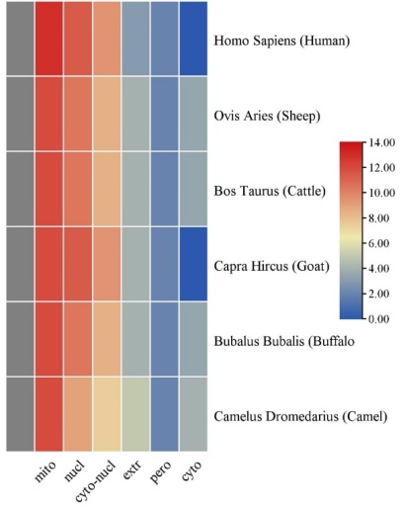

**Figure (S1).** Expression of HSP27 protein in different organelles

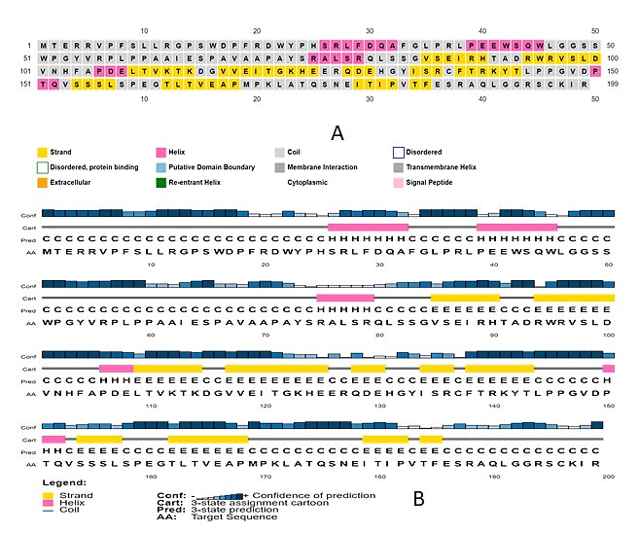

**Figure (S2).** Secondary structure of human HSP27 protein

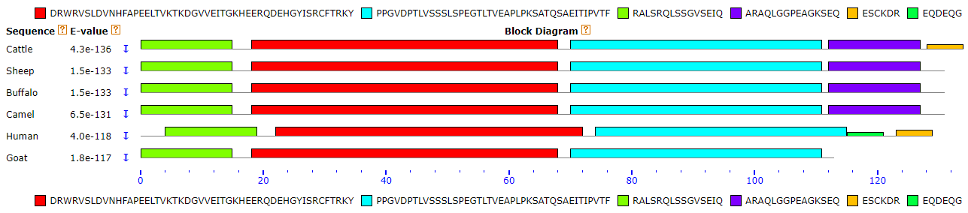

**Figure (S3)** Motifs of each organism’s protein sequence and each motif represent E &P value with different colors.



**Figure (S4)** Phylogenetic tree showing evolutionary relationship among different organisms constructed by MEGA 7. 0